Story of Place - Teacher Exemplar
Grade 5/6 Arts Education - an example of the finished ink and marker artwork students create
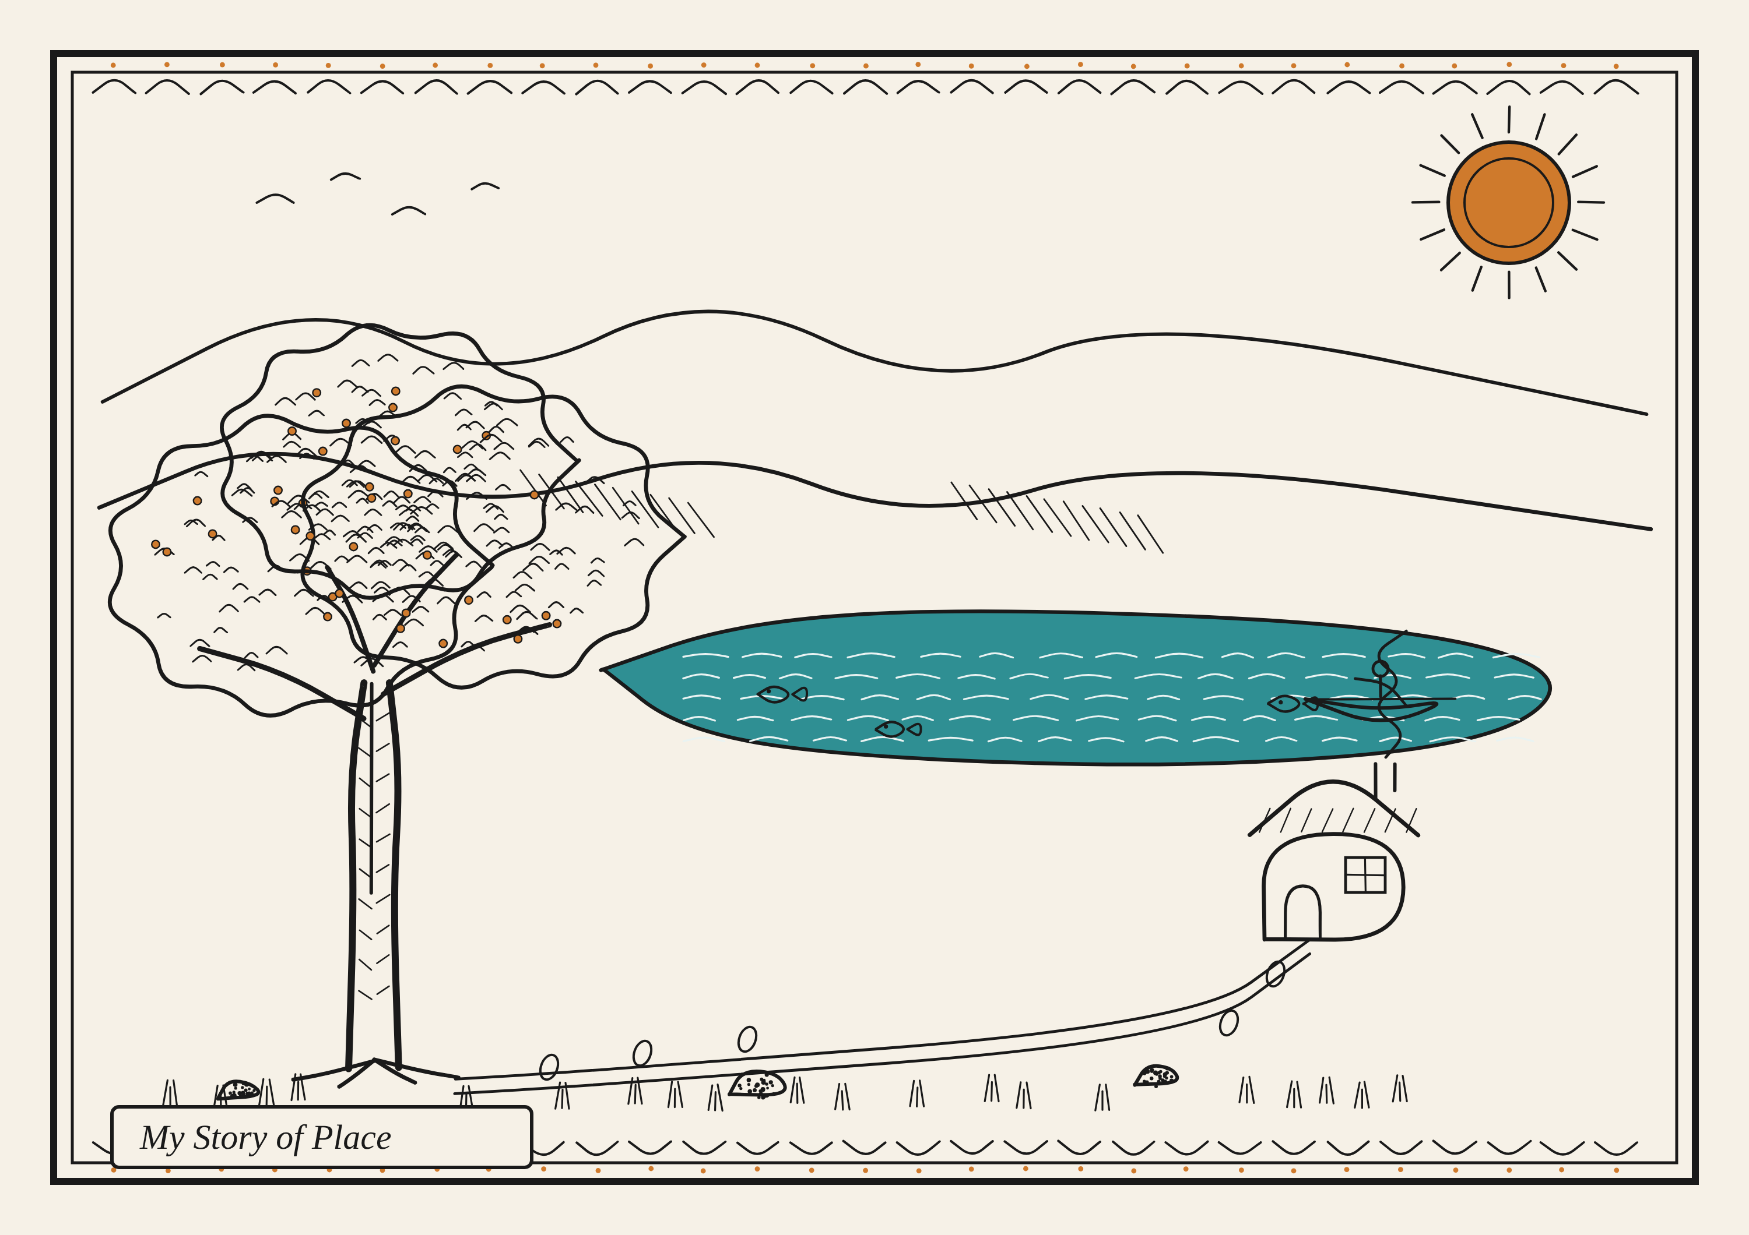
How to read this exemplar
This is one original artwork built only from the artist's own invented symbols and line techniques. It is a model, not a template. Students learn from and honour how Syilx artists tell stories of place, then design their OWN symbols and their OWN story. We never copy Syilx, sacred, or specific designs.
Model artist statement (what a student might write)
"My story of place is the lake where my family walks every summer. The big tree stands for my family: deep roots and always growing. The lake is where I feel calm, and the canoe is for the mornings I paddle with my grandpa. The trail and footprints are our walk home to the cabin. I used thick and thin lines, pattern in the water and leaves, and two accent colours to make the tree and sun stand out."
Symbol key (this artist's choices)
Symbol | What it means to the artist
Big tree (focal point) | Family: deep roots and steady growth
Lake | A place where I feel calm
Canoe | Mornings paddling with my grandpa
Trail and footprints | Our walk home; journeys we take
Cabin with smoke | Home and warmth
Sun and birds | New mornings and freedom
Mountains | The land that holds us

Techniques shown: line variety (thick and thin), pattern and texture (water, leaves, bark, border), contrast, emphasis (the tree as focal point), and two accent marker colours.

